Id | Name | Marke | Belag Art | Menge Rot | Menge Schwarz | Preis | Bild
1 | EVOLUTION MX-P | TIBHAR | Noppen-innen | 20 | 30 | 45,00 | 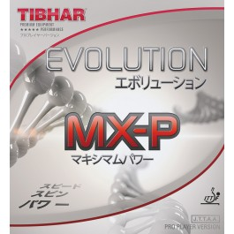
2 | EVOLUTION EL-S | TIBHAR | Noppen-innen | 20 | 50 | 45,00 | 
3 | Evolution FX-S | TIBHAR | Noppen-innen | 30 | 10 | 45,00 | 
4 | Evolution EL-P | TIBHAR | Noppen-innen | 10 | 80 | 45,00 | 
5 | Tibhar Evolution FX-P | TIBHAR | Noppen-innen | 90 | 50 | 45,00 | 
6 | VARI SPIN | TIBHAR | Noppen-innen | 10 | 700 | 30,00 | 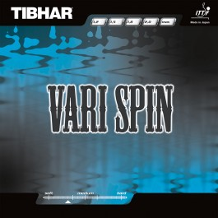
7 | Rapid | TIBHAR | Noppen-innen | 40 | 20 | 30,00 | 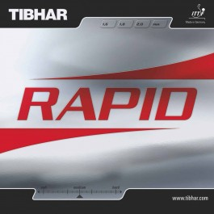
8 | Speedy Soft | TIBHAR | kurze Noppen | 20 | 60 | 35,00 | 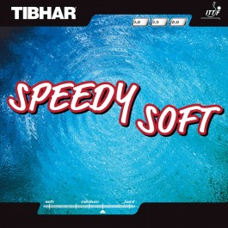
9 | Grass D-TecS | TIBHAR | lange Noppen | 80 | 70 | 35,00 | 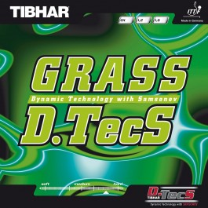
10 | Ellen | TIBHAR | Anti | 60 | 40 | 20,00 | 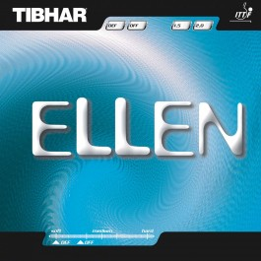

Id | Name | Marke | Belag Art | Menge Rot | Menge Schwarz | Preis | Bild
11 | Reflection | Der Materialspezialist | Anti | 20 | 30 | 60,00 | 
12 | Scandal | Der Materialspezialist | Anti | 30 | 40 | 55,00 | 
13 | Elite Long | Der Materialspezialist | lange Noppen | 70 | 20 | 35,00 | 
14 | Coppa | Donic | Noppen-innen | 20 | 40 | 30,00 | 
15 | Acuda S1 | Donic | Noppen-innen | 40 | 10 | 40,00 | 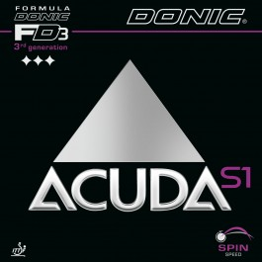
16 | Acuda S2 | Donic | Noppen-innen | 10 | 60 | 40,00 | 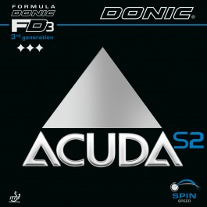
17 | Acuda S3 | Donic | Noppen-innen | 40 | 40 | 40,00 | 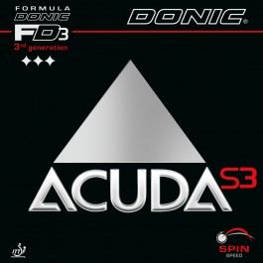
18 | Donic Baracuda | Donic | Noppen-innen | 70 | 20 | 40,00 | 
19 | Desto F1 | Donic | Noppen-innen | 30 | 40 | 30,00 | 
20 | Liga | Donic | Noppen-innen | 90 | 40 | 15,00 | 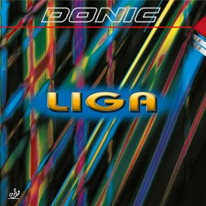

Id | Name | Marke | Belag Art | Menge Rot | Menge Schwarz | Preis | Bild
21 | Waran | SpinLord | kurze Noppen | 40 | 10 | 20,00 | 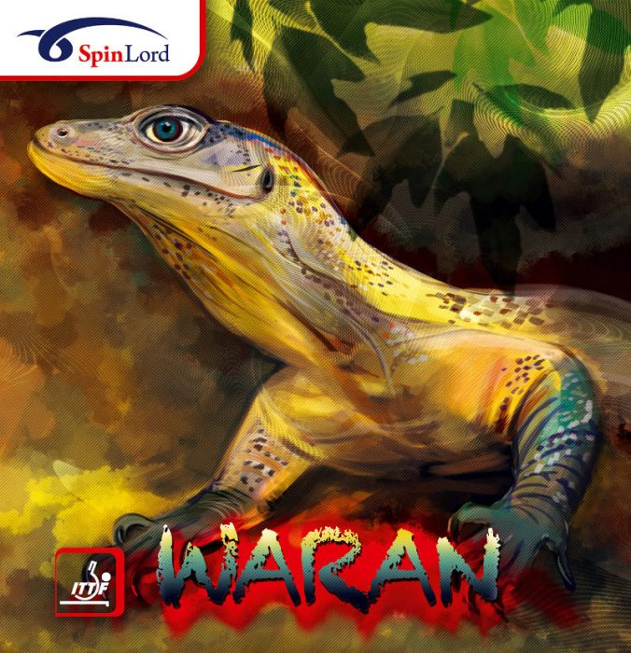
22 | Keiler | SpinLord | mittellange Noppen | 30 | 30 | 20,00 | 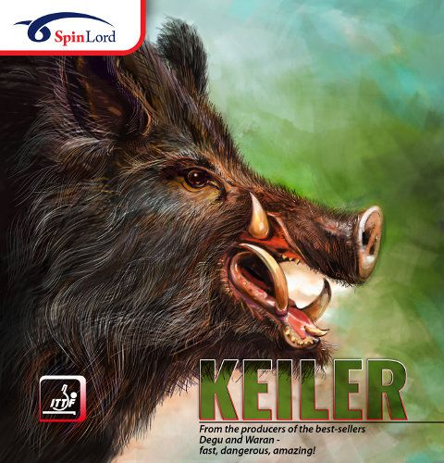
23 | Degu | SpinLord | kurze Noppen | 70 | 40 | 25,00 | 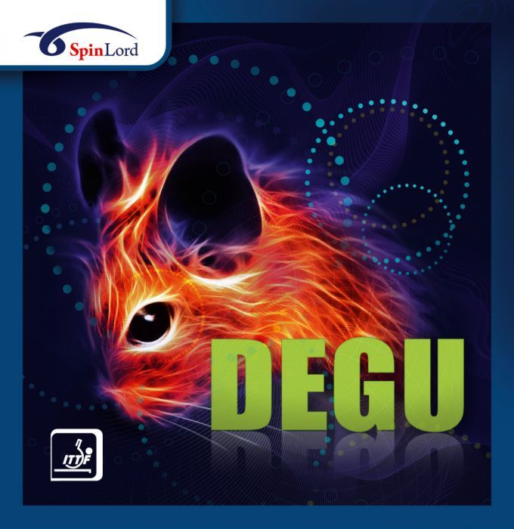
24 | Feuerstich | SpinLord | lange Noppen | 10 | 20 | 15,00 | 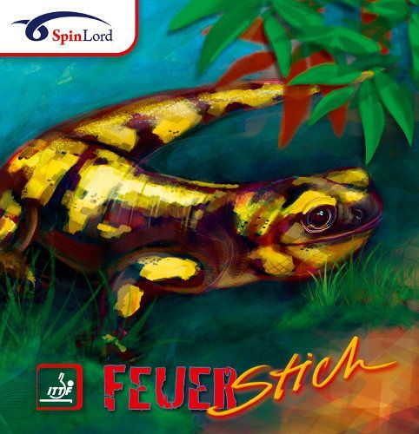
25 | Gigant | SpinLord | Anti | 20 | 20 | 15,00 | 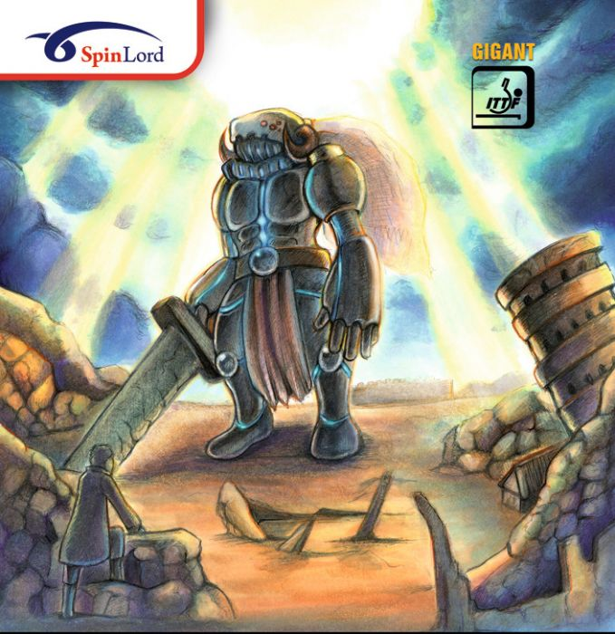
26 | RITC | Friendship 729 | Noppen-innen | 30 | 20 | 10,00 | 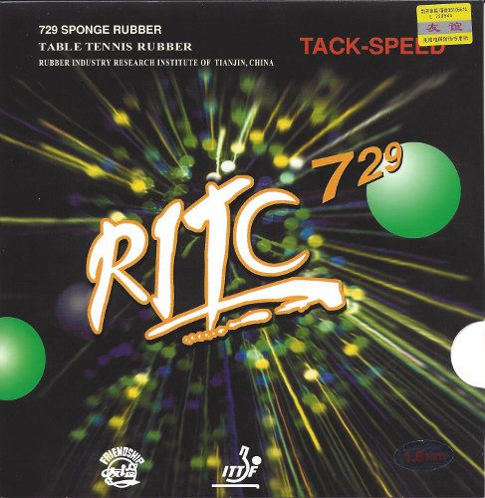
27 | Geospin | Friendship 729 | Noppen-innen | 50 | 10 | 5,00 | 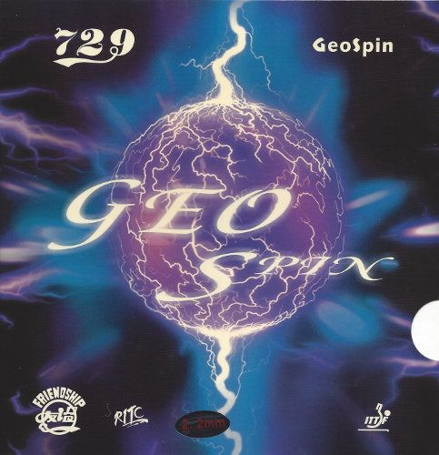
28 | Bloom Spin | Friendship 729 | Noppen-innen | 70 | 20 | 25,00 | 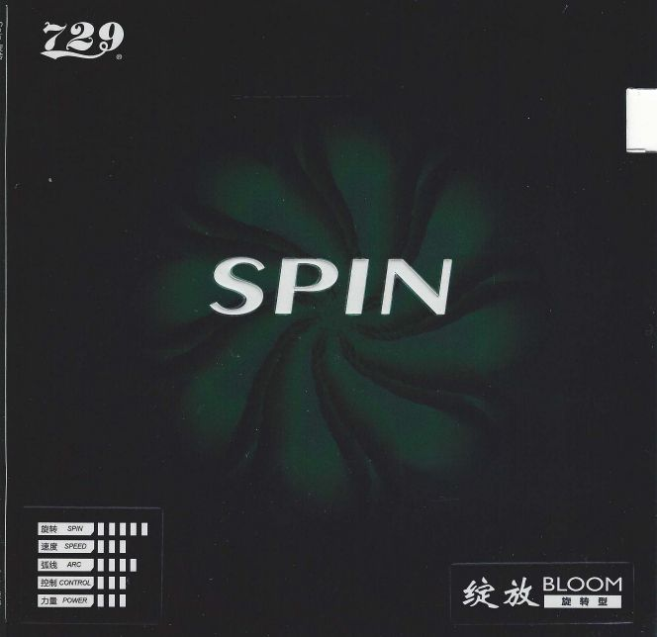
29 | Focus 2 | Friendship 729 | Noppen-innen | 20 | 50 | 15,00 | 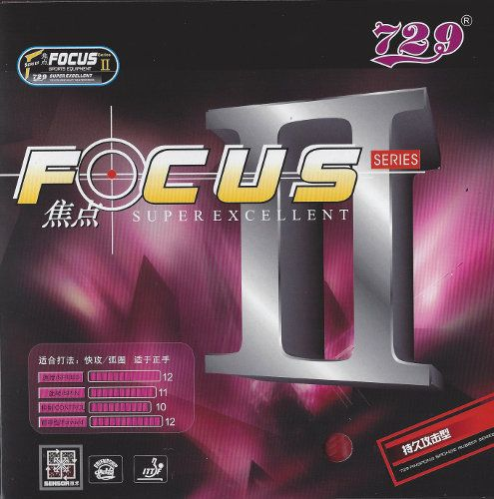
30 | Bloom Power | Friendship 729 | Noppen-innen | 90 | 10 | 25,00 | 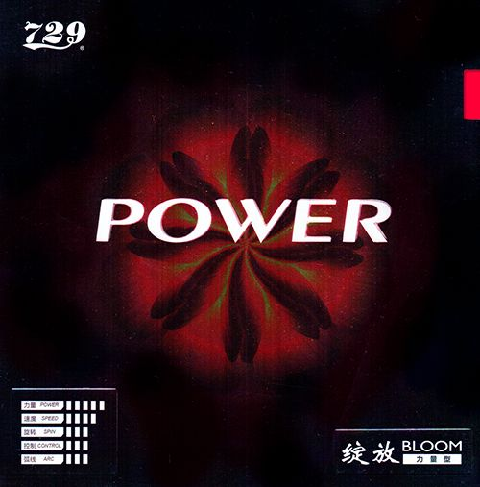

Id | Name | Marke | Belag Art | Menge Rot | Menge Schwarz | Preis | Bild
31 | Aggressor | Lion | Noppen-innen | 20 | 30 | 5,00 | 
32 | Roar | Lion | Noppen-innen | 30 | 10 | 20,00 | 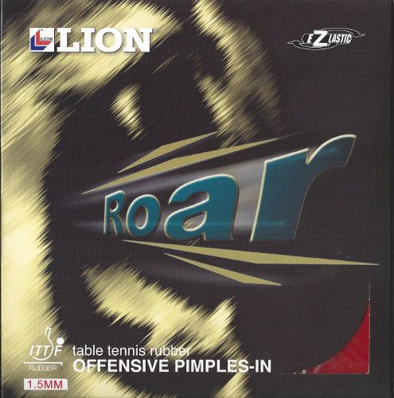
33 | Mantlet | Lion | Anti | 40 | 20 | 15,00 | 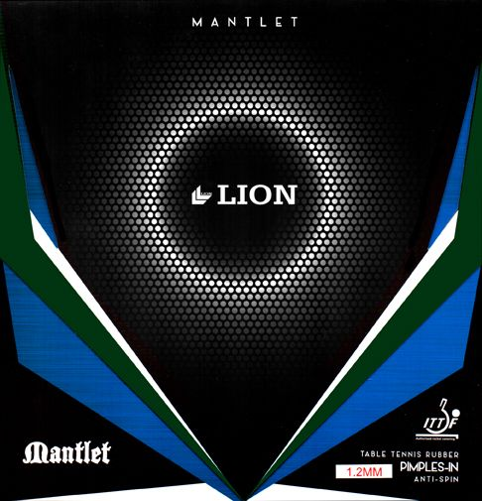
34 | Amigo | Palio | Noppen-innen | 40 | 40 | 15,00 | 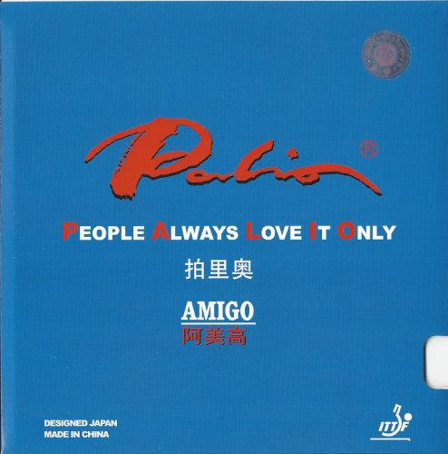
35 | Conqueror | Palio | Noppen-innen | 90 | 20 | 10,00 | 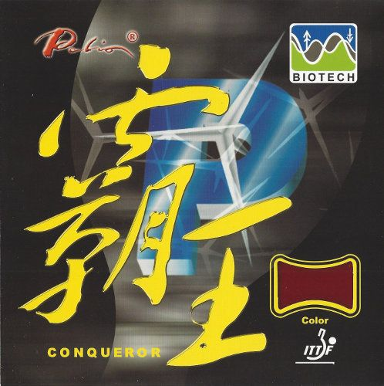
36 | AK 47 blue | Palio | Noppen-innen | 40 | 60 | 20,00 | 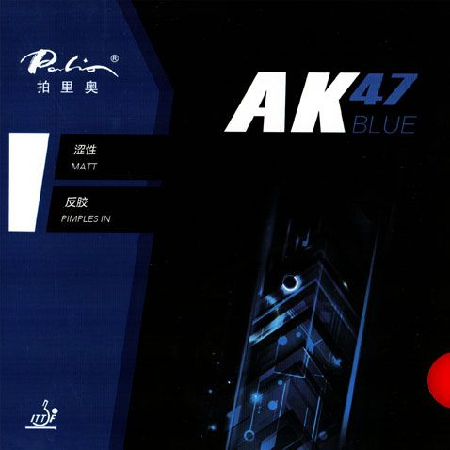
37 | AK 47 red | Palio | Noppen-innen | 60 | 40 | 20,00 | 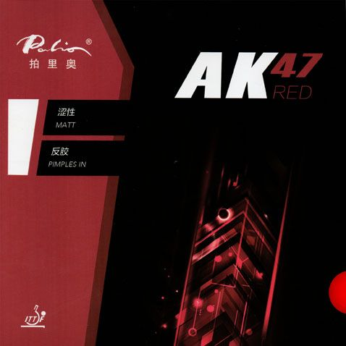
38 | AK 47 yellow | Palio | Noppen-innen | 50 | 50 | 20,00 | 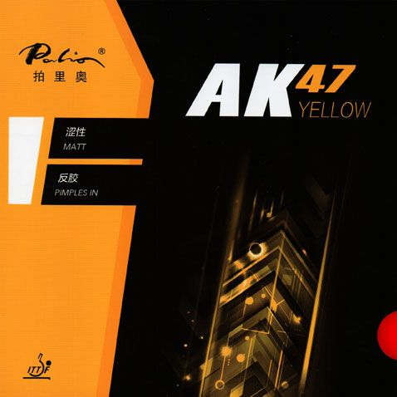
39 | Peril Anti | Giant Dragon | Anti | 40 | 20 | 20,00 | 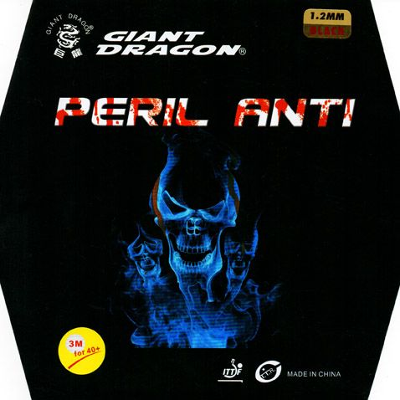
40 | Cropcircles | Giant Dragon | lange Noppen | 90 | 10 | 15,00 | 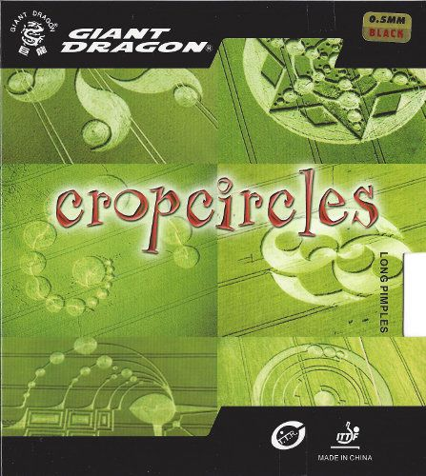

Links für Bilder
https://www.tt-shop.de
https://ttdd.eu

